You are invited to enter the
Isle of Wight
Rural Awards 2020
In their third year, the Isle of Wight Rural Awards, sponsored by the CLA and Royal Isle of Wight Agricultural Society, will celebrate the very best of rural life on the Isle of Wight.

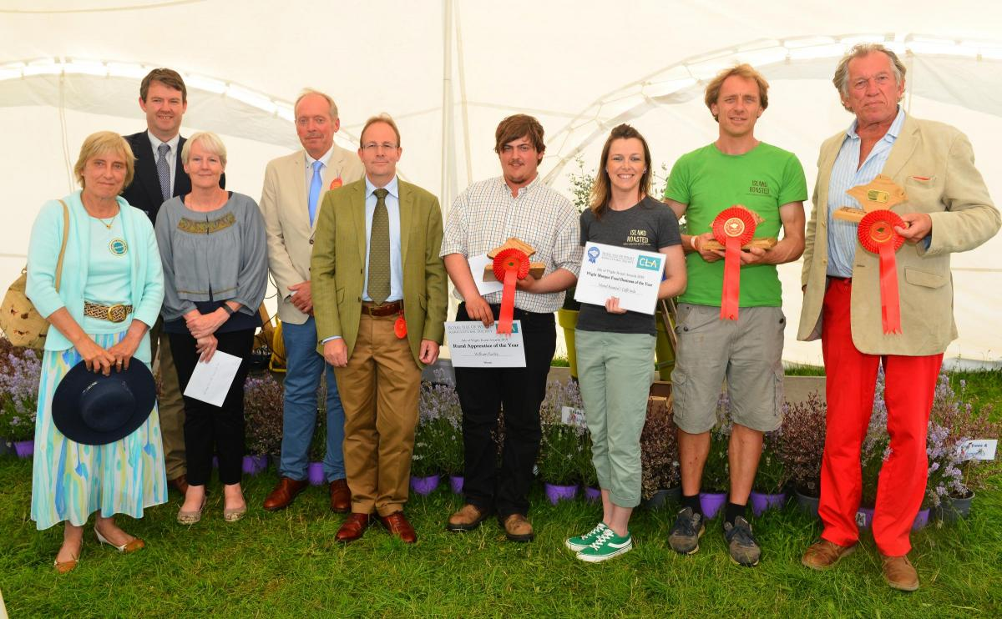
The Lord Lieutenant, judges and a selection of the 2019 winners.

Isle of Wight Rural Awards 2020
Sponsored by the CLA and Royal Isle of Wight Agricultural Society (RIWAS)
Categories
- Rural Business of the Year – awarded to the rural business, from any sector or size, who exemplifies the Island’s rural sector and has made a significant contribution to the Isle of Wight. Selected from the winners in each of the four business categories:

  - Wight Marque Food Business – awarded to the Wight Marque business which has contributed the most to profile and promote the Isle of Wight as a quality food destination
  - Rural Tourism Business – awarded to the tourism business which has contributed the most to the Island’s rural tourism sector
  - Countryside Small Business – awarded to any type of business employing 5 or fewer people.
  - Countryside Business - awarded to any type of business employing 6 or more people.

- Rural Young Person of the Year – awarded to the young person aged 26 or under who lives, works or has a connection to the Isle of Wight countryside and has made a valued contribution to the rural sector.

- Lifetime Achievement Award – awarded to the person who it is considered has contributed greatly to the rural sector over a sustained period of time. This category is not open to nominations, with the nominees and winner chosen by the judging panel. This may not be awarded each year.
Please complete the application form and give as much detail as possible about why you think the person or business you have nominated should receive the award. You can nominate yourself, or others, and do so in more than one category if you wish.
Nominations close on 16th October.
All entries will be assessed by a panel of members from the RIWAS and the CLA.
Visits may be made to shortlisted entrants according to Covid-19 regulations. The decision of the panel is final.
If you have any enquiries, please contact RIWAS on 0845 226 9098 or riwas@naturalenterprise.co.uk

Isle of Wight Rural Awards 2020
Your name
Address
Email |  |  |  | Telephone
Name of business/person/organisation you are nominating:
Their address
Their email
Please indicate the category(ies)
☐ |  | Wight Marque Food Business
☐ |  | Rural Tourism Business
☐ |  | IW Countryside Small Business
☐ |  | IW Countryside Business
☐ |  | Rural Young Person of the Year
Why do you believe you / they deserve this award? Please give as much detail as possible, and continue on another sheet if necessary.
Please return this form to riwas@naturalenterprise.co.uk, or by post to Shide Meadows Centre, Shide Road, Newport, Isle of Wight PO30 1HR before 16th October 2020.

